**Informatica 9 & OBIEE (Oracle Business Intelligence Enterprise Edition) 11g**

**Duration : 2 ½ - 3 Months**

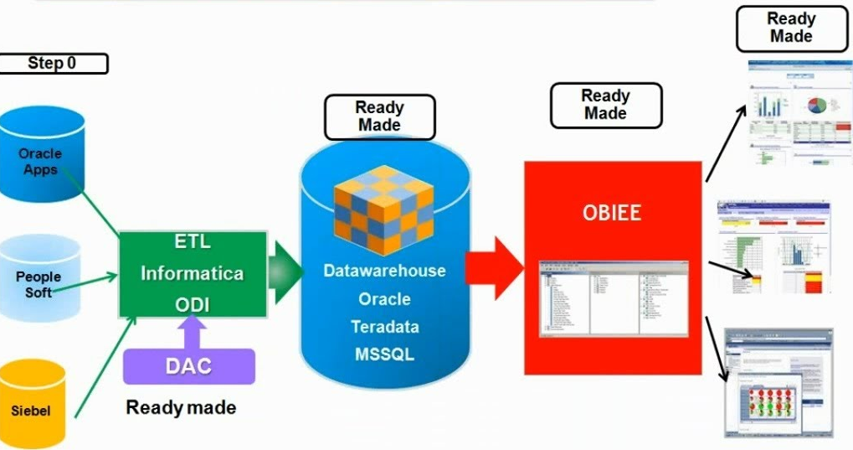

**Data Warehouse Concept:**

**Section 1 : Introduction**

* Need of Data Warehouse
* Purpose of Analysis
* Evolution of Reporting
* SDLC of Data Warehouse
* Importance of Transaction Systems – OLTP
* Characteristics of OLTP

**Section 2 : Architecture of Data Warehouse**

* Definition of Data Warehouse
* Architecture of Data Warehouse
* Characteristics of Data Warehouse
* Difference Between OLTP – OLAP
* Dimensional Modeling
* Dimension and Fact Tables
* Types of Dimensions and Facts
* Star Schema , Snowflake Schema
* Slowly Changing Dimension Type I, Type II, Type III
* Grain Level

**Section 3 : Implementation Methodology**

* Data Mart
* Difference Between Data Mart and Data warehouse
* Bill Inmon Methodology and Kimball Methodology
* Data Loading : Full Load, Normal Load, Incremental Load

**Informatica 9**

**Section 1 : Introduction and Architecture**

* Introduction of informatica
* Architecture of Information – Power center 9.1/9.5
* Informatica Design Process
* Informatica Client Tool – Designer
* Difference between Power Mart and Power Center
* Source Analyzer and Warehouse Designer

**Section 2 : Mapping Designer**

* Create a Simple Mapping
* Overview of Transformation
* Types of Transformations – Active and Passive
* Active vs Passive Transformations
* Connected vs Unconnected Transformation
* Introduction to workflow Manager
* Task Developer
* Workflow Designer
* Worklet Designer

**Section 3 : Flat Files Handling**

* Create Simple Mappings
* Flat File Analysis
* Scenarios of Flat File Loading

**Section 4 : Transformation - 1**

* Source Qualifier Transformation
* Properties of Source Qualifier Transformation
* Scenarios of SQ Transformations
* Using Join in a Source Qualifier Transformation
* Joiner Transformation
* Union Transformation
* Lookup Transformation

**Section 6 : Transformation Condition -1**

* Multiple Targets Loading
* Filter Transformation
* Router Transformation
* Scenarios & example of Transformation

**Section 7 : Transformation Condition -2**

* Sorter Transformation
* Aggregator Transformation
* Expression Transformation
* Scenarios & Examples of Transformation

**Section 8 : Transformation Condition – 3**

* Rank Transformation
* Sequence Generator Transformation
* Normalizer Transformation
* Scenarios & examples of Transformation

**Section 9 : Transformation Condition – 4**

* Stored Procedure Transformation
* SQL Transformation
* Java Transformation
* Scenarios & Examples of Transformation

**Section 10 : Transformation Condition – 5**

* Mapplet & types of Mapplets
* Mapplet input
* Mapplet Output

**Section 11 : Transformation Condition – 6**

* Update Strategy Transformation
* Transaction Control Transformation
* XML Source Qualifier Transformation

**Section 12 : Advanced and Performance Tunning Part**

* File list Concept (indirect Method)
* How to Backup the file in informatica
* How to extract the Differences Sources( nothing but excel, ms access, sql server, my sql , db2, tera data, xml file)
* SCD Type-1 , SCD Type-2 , SCD Type-3
* Mapping Parameter & Variables
* Constraint loading & Target Load plan
* Incremental Loading & Aggregation
* Types of Caches, (Dynamic Cache, Persistent Cache, re cache)
* Types of Task ( Timer Task , Command Task ,Assignment Task,

Decision Task , Event Wait & Event Raise)

* Debugger
* Worklet Designer
* Lookup Override Example
* Unconnected Lookup & Stored Procedures

**Section : 13 : DAC**

* DAC Introduction
* How to Schedule the Workflows in DAC

**OBIEE (Oracle Business Intelligence Enterprise Edition) 11g**

**Section 1 : Overview of OBIEE 11G**

* What is OBIEE?
* Introduction to OBIEE 11g?
* End to End Life Cycle of OBIEE 11g?
* Oracle BI Architecture 11g
* Oracle BI Components 11g

**Section 2 : Installation of OBIEE 11g**

* Oracle 11g Database
* Web logic server 10g/11g
* OBIEE 11g

**Section 3 : RPD & Catalog Basis**

* Repository basis
* Metadata and Catalog basis
* Physical , BMM , Presentation Layers Overview
* RPD Online Mode and Offline Mode
* Answers, Dashboards, Administration
* Repository & Catalog Deployment
* Start & Stop Web logic & BI Service
* Administration Files, Logs, Services, Folders
* OPMN

**Section 4 : Repository ( Physical Layer )**

* + Creating New Repository
  + Import Metadata
  + Verify Connections
  + Properties of Physical Layer Objects
  + Creating Aliases, Physical Keys and Joins

**Section 5 : Layer of Repository ( BMM )**

* + Creating Business Model
  + Properties of BMM Layer Objects
  + Examine Logical Joins , Logical Columns , LTS
  + Rename Logical Objects Manually & Rename Logical Objects using the rename wizard
  + Delete Unnecessary Logical Objects
  + Create Simple Measures

**Section 6 : Layer of Repository (Presentation )**

* Creating Presentation Layer Objects
* Properties of Presentation Layer Objects
* Rename Presentation Columns
* Reorder Presentation Columns
* Creating Nested Structure

**Section 7 : Testing & Validating a Repository**

* Check Global Consistency
* Load the Repository
* Understanding Logging Levels
* Set Up Query Logging
* Validating Query Logging

**Section 8 : Managing LTS, Calculated Measure**

* Add a New Logical Table Source
* Create Presentation Layer Objects & Validation of Multiple LTS
* Create a Calculation Measure Derived from Existing Columns
* Create a Calculation Measure Using a Function

**Section 9 : Dimension Hierarchies , Level based Measures**

* Creating Dimension Hierarchies
* Creating Level Based Measures
* Validating Drill Down feature

**Section 10 : Creating Level Based Measures**

* Modelling Aggregate Tables
* Creating Ragged & Skipped Level Hierarchy
* Validating Aggregate Navigation

**Section 11 : Functions & Variables**

* Calendar Date/Time Functions , Conversion Functions
* Display Functions , Evaluate Functions
* Lookup Functions , Mathematics Functions
* String Functions , System Functions , Time Series Functions
* Understanding Variables
* Creating Session Variables & Creating Repository Variables
* Creating Initialization Blocks & Referencing Variables

**Section 12 : Cache Management**

* Enable/Disable Cache, Managing Cache in RPD
* Validating Cache
* Managing Cache using EM
* Purging Cache , Using Cache Functions

**Section 13 : Formatting , Sorting , Filters and Working with Different Report Views**

* Formatting & Sorting the Reports
* Creating Saved Filters , Creating Filters
* Title View , Table, Pivot View ,Graphs, Gauges, Legend
* Narrative View,Static Text,Column/View Selector

**Section 14 : Creating Dashboards, Prompts , Presentation Variables , Dashboard Pages, Union Reports , Practical Scenarios**

* Creating Prompts , Creating Dashboards
* Running a Dynamic Report on a Dashboard , Working with Presentation Variables
* Creating Dashboard Pages , Advanced Dashboard Properties
* Creating Union Reports , Practical Scenarios

**Section 15 : Scorecard & KPI’s**

* Creating KPIs, KPI Watch list, Scorecards
* Displaying Scorecards on a Dashboard

**Section 16 : Security Administrator**

* Understanding Authentication, Authorization
* Understanding Permissions, Privileges
* Understanding Users, Groups, Application Roles
* Working on RPD Merging