CATALOG OF LOUPES

Flip Up Galilean Loupes 2.5x 3.0x 3.5x

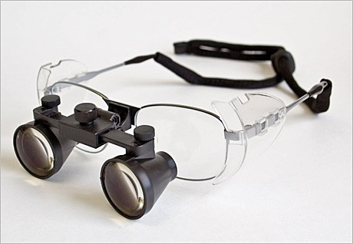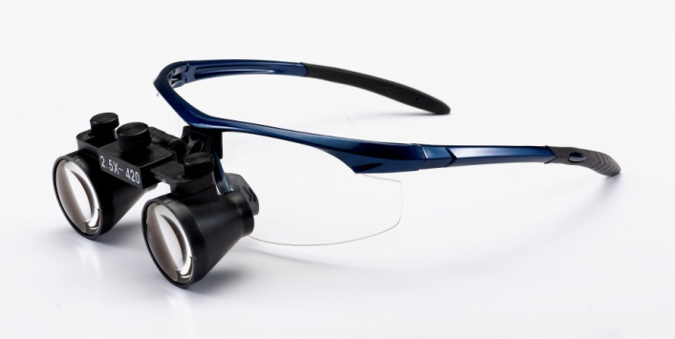
Light weight, Galilean type binocular loupes. Maximum ease of use, combined with multi-functional capabilities. Available in a variety of working distances for your maximum comfort .Multi-coated precision lenses for superb clarity and reduced reflection. Ultra light-weight body and frame for maximum comfort. Fully adjustable viewing angle, pupil distance and flip-up function.
Galilean Flip Up is the most popular model. It offers the widest field of view and longest depth of focus. It has excellent clear view and great optical capability to provide the operator with the optimal magnification while providing extended field of view
Items | magnification | working distance | field of view | depth of view | weight
250S | 2.5X | 340mm | 90mm | 80mm | 50g
250R | 2.5X | 420mm | 100mm | 90mm | 50g
250L | 2.5X | 500mm | 110mm | 110mm | 50g
250XL | 2.5X | 550mm | 125mm | 120mm | 50g
300S | 3.0X | 340mm | 60mm | 60mm | 56g
300R | 3.0X | 420mm | 65mm | 80mm | 56g
300L | 3.0X | 500mm | 70mm | 90mm | 56g
300XL | 3.0X | 550mm | 75mm | 100mm | 56g
350S | 3.5X | 340mm | 55mm | 60mm | 58g
350R | 3.5X | 420mm | 60mm | 80mm | 58g
350L | 3.5X | 500mm | 65mm | 90mm | 58g
350XL | 3.5X | 550mm | 70mm | 100mm | 58g
adjustment | Flip up style. Adjustable view angel : 0 - 45°
pupil distance | adjustable: 46mm-70mm. Center adjustment
available frames | Sports frames, Ni-alloy frames, Titanium frames,

Flip Up Prismatic Loupes 4.0X 5.0X 6.0X

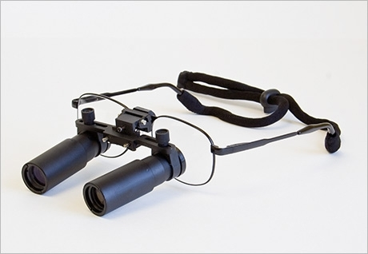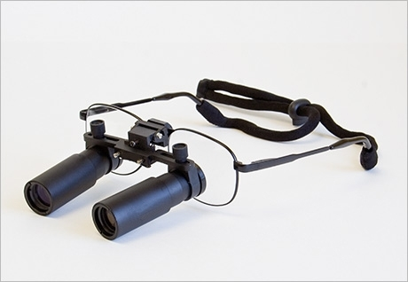
uses a prism system, which offers very clear image. Camber hinge offers comfortable view angle. Prism system give you a wider field of view with maximum magnification. flip-up, dental loupes & surgical loupes, offer the maximum ease of use, combined with multi-functional capabilities, Available in a variety of magnification & working distances

items | magnification | working distance | field of view | depth of view | weight
400S | 4.0X | 340mm | 50mm | 40mm | 78g
400R | 4.0X | 420mm | 55mm | 40mm | 78g
400L | 4.0X | 500mm | 60mm | 40mm | 78g
400XL | 4.0X | 550mm | 70mm | 40mm | 78g
500S | 5.0X | 340mm | 40mm | 35mm | 82g
500R | 5.0X | 420mm | 45mm | 35mm | 82g
500L | 5.0X | 500mm | 50mm | 35mm | 82g
500XL | 5.0X | 550mm | 60mm | 35mm | 82g
600S | 6.0X | 340mm | 40mm | 25mm | 82.5g
600R | 6.0X | 420mm | 45mm | 25mm | 82.5g
600L | 6.0X | 500mm | 50mm | 25mm | 82.5g
600XL | 6.0X | 550mm | 55mm | 25mm | 82.5g
adjustment | Flip up style. Adjustable view angel : 0 - 45°
pupil distance | adjustable: 48mm-80mm.individual adjustment
Available frames | Ni-alloy frames, Titanium frames,

Flip Up waterproof designing Galilean Loupes 2.5x 3.0x 3.5x
Light weight, Galilean type binocular loupes. Maximum ease of use, combined with multi-functional capabilities. Available in a variety of working distances for your maximum comfort .Multi-coated precision lenses for superb clarity and reduced reflection. Ultra light-weight body and frame for maximum comfort. Fully adjustable viewing angle, pupil distance and flip-up function.
Galilean Flip Up is the most popular model. It offers the widest field of view and longest depth of focus. It has excellent clear view and great optical capability to provide the operator with the optimal magnification while providing extended field of view
Waterproof designing loupes is real waterproof loupes. other description is about same as the regular Galilean Loupes
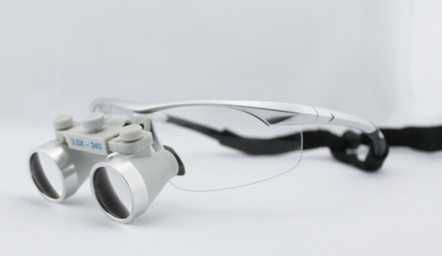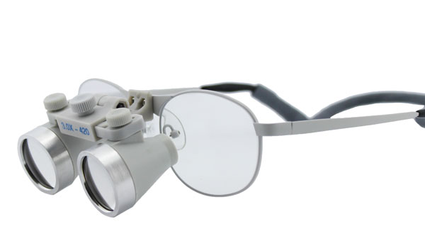
Items | magnification | working distance | field of view | depth of view | weight
250S | 2.5X | 340mm | 90mm | 80mm | 52g
250R | 2.5X | 420mm | 100mm | 90mm | 52g
250L | 2.5X | 500mm | 110mm | 110mm | 52g
250XL | 2.5X | 550mm | 125mm | 120mm | 5g
300S | 3.0X | 340mm | 60mm | 60mm | 58g
300R | 3.0X | 420mm | 65mm | 80mm | 58g
300L | 3.0X | 500mm | 70mm | 90mm | 58g
300XL | 3.0X | 550mm | 75mm | 100mm | 58g
350S | 3.5X | 340mm | 55mm | 60mm | 60g
350R | 3.5X | 420mm | 60mm | 80mm | 60g
350L | 3.5X | 500mm | 65mm | 90mm | 60g
350XL | 3.5X | 550mm | 70mm | 100mm | 60g
adjustment | Flip up style. Adjustable view angel : 0 - 45°
pupil distance | adjustable: 46mm-70mm. Center adjustment
available frames | Sports frames, Ni-alloy frames, Titanium frames,

Normal TTL Loupes (Through the Lens) 2.5X 3.0X 3.5X
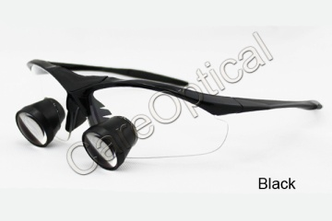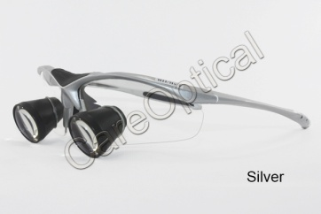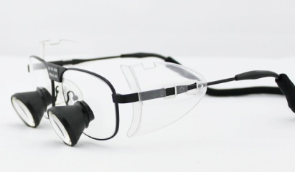

Normal TTL style: TTL stands for “Through The Lens”, It means that the loupes are glued to your lens. Although TTL is slightly lighter than Flip-Up system, it can not be moved from line of vision and the user can not make adjustments to the angle of declination to accommodate for the patient’s position. And since each pair of TTL loupes is custom made, it is much more expensive than the Flip-Up loupes。The loupes Through The Lens are light weight, and laconic appearance. It has fashionable design and comparable with designer frames
items | magnification | working distance | field of view | depth of view | weight
250S | 2.5X | 340mm | 90mm | 80mm | 45g
250R | 2.5X | 420mm | 100mm | 90mm | 45g
250L | 2.5X | 500mm | 110mm | 110mm | 45g
250XL | 2.5X | 550mm | 125mm | 120mm | 45g
300S | 3.0X | 340mm | 60mm | 60mm | 50g
300R | 3.0X | 420mm | 65mm | 80mm | 50g
300L | 3.0X | 500mm | 70mm | 90mm | 50g
300XL | 3.0X | 550mm | 75mm | 100mm | 50g
350S | 3.5X | 340mm | 55mm | 60mm | 65g
350R | 3.5X | 420mm | 60mm | 80mm | 65g
350L | 3.5X | 500mm | 65mm | 90mm | 65g
350XL | 3.5X | 550mm | 70mm | 100mm | 65g
adjustment | TTL style is not adjustable view of angle. And pupil distance is not adjustable
pupil distance | three pupil distance optional: 59-61mm ; 61-63mm ; 63-65mm or according to require
aiviable frames | Sports frames, Ni-alloy frames, Titanium frames,
New improved Sports Frames TTL loupes can be mounted prescription lens. There is a inside lens sheet as standard accessory. The inside lens sheet can be mounted prescription lens.
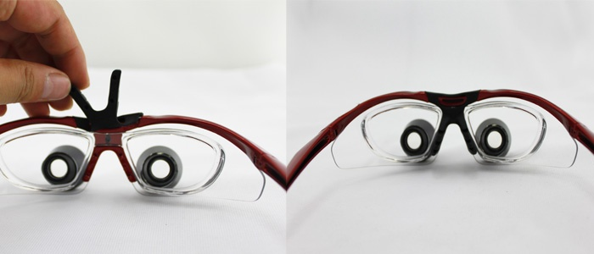
Headband Galilean loupes 2.5x 3.0x 3,5X
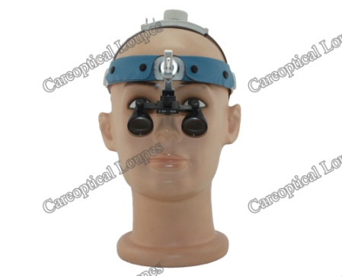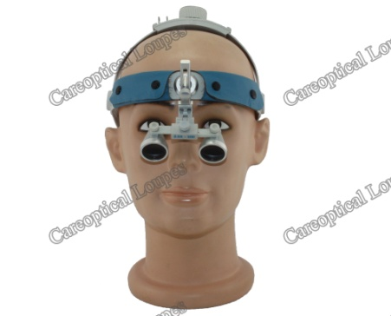
Using Headband Style, the size of Headband is adjustable. Light weight, Galilean type binocular loupes. Maximum ease of use, combined with multi-functional capabilities. Available in a variety of working distances for your maximum comfort .Multi-coated precision lenses for superb clarity and reduced reflection. Ultra light-weight body andheadband for maximum comfort. Fully adjustable viewing angle, pupil distance and flip-up function.

Items | magnification | working distance | field of view | depth of view | weight
250S | 2.5X | 340mm | 90mm | 80mm | 45g
250R | 2.5X | 420mm | 100mm | 90mm | 45g
250L | 2.5X | 500mm | 110mm | 110mm | 45g
250XL | 2.5X | 550mm | 125mm | 120mm | 45g
300S | 3.0X | 340mm | 60mm | 60mm | 51g
300R | 3.0X | 420mm | 65mm | 80mm | 51g
300L | 3.0X | 500mm | 70mm | 90mm | 51g
300XL | 3.0X | 550mm | 75mm | 100mm | 51g
350S | 3.5X | 340mm | 55mm | 60mm | 55g
350R | 3.5X | 420mm | 60mm | 80mm | 55g
350L | 3.5X | 500mm | 65mm | 90mm | 55g
350XL | 3.5X | 550mm | 70mm | 100mm | 55g
adjustment | Flip up style. Adjustable view angel : 0 - 45°
pupil distance | adjustable: 46mm-70mm. Center adjustment
available frames | Headband style, no eyewear frames (weight not include the headband)

Headband Prismatic loupes 4.0x 5.0x 6.0. 7.0x 8.0x
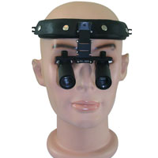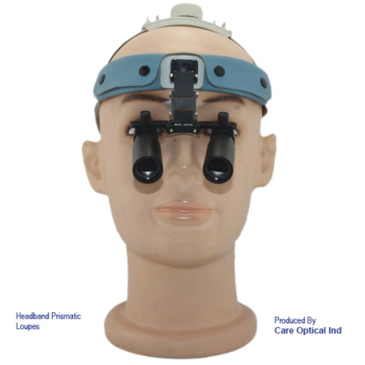
using a prism system, which offers very clear image. Camber hinge offers comfortable view angle. Prism system give you a wider field of view with maximum magnification. flip-up function , headband style, offer the maximum ease of use, combined with multi-functional capabilities, Available in a variety of magnification & working distances. because the Kepler loupes is prismatic loupes, so they are heavy. regarding the normal eyewear style ,doctors will be uncomfortable for a long time using. the headband style is a good designing resolve this problem. headband can be adjustable according to different size of users' head. the headband style is good design, when need use the loupes, just plug the loupes on the headband (because we design the parts for easy mounted on), very easy, when you need the loupes on stork, just release the loupes from the headband putting on the bag.
items | magnification | working distance | field of view | depth of view | weight
400S | 4.0X | 370mm | 53mm | 40mm | 78g
400R1 | 4.0X | 420mm | 55mm | 40mm | 78g
400R2 | 4.0X | 460mm | 58mm | 40mm | 78g
400L | 4.0X | 500mm | 60mm | 40mm | 78g
400XL | 4.0X | 550mm | 70mm | 40mm | 78g
500S | 5.0X | 370mm | 43mm | 35mm | 82g
500R1 | 5.0X | 420mm | 45mm | 35mm | 82g
500R2 | 5.0X | 460mm | 48mm | 35mm | 82g
500L | 5.0X | 500mm | 50mm | 35mm | 82g
500XL | 5.0X | 550mm | 60mm | 35mm | 82g
600S | 6.0X | 340mm | 43mm | 25mm | 82.5g
600R | 6.0X | 420mm | 45mm | 25mm | 82.5g
600R2 | 6.0X | 460mm | 48mm | 25mm | 82.5g
600L | 6.0X | 500mm | 50mm | 25mm | 82.5g
600XL | 6.0X | 550mm | 55mm | 25mm | 82.5g
adjustment | Flip up style. Adjustable view angel : 0 - 45°
pupil distance | adjustable: 48mm-80mm.individual adjustment
Available frames | Headband style, without frames

Clip-on loupes 2.5X 3.0X 3.5X

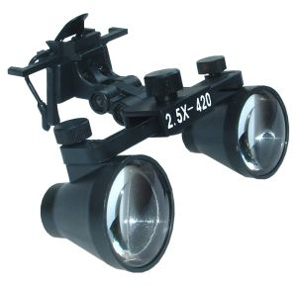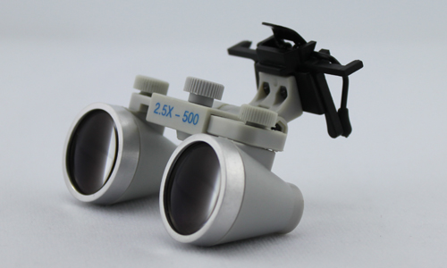
Clip On Loupes can be the most flexible and effective solution for surgeons, dentists, and dental hygienists. Clip-on style loupes can be attached to virtually any frame of glasses. If you are myopia or hyperopia, you can use our clip-on loupes on your own frame, it is very convenient, removable, with ease of use. We have 2.5x, 3x and 3.5x with the clip-on type. 4x, 5x and 6x are not available with clip-on type .there are regular loupes clip on style and waterproof designing loupes clip on style
items | magnificaion | working distance | field of view | depth of view | weight
250S | 2.5X | 340mm | 90mm | 80mm | 45g
250R | 2.5X | 420mm | 100mm | 90mm | 45g
250L | 2.5X | 500mm | 110mm | 110mm | 45g
250XL | 2.5X | 550mm | 125mm | 120mm | 45g
300S | 3.0X | 340mm | 60mm | 60mm | 51g
300R | 3.0X | 420mm | 65mm | 80mm | 51g
300L | 3.0X | 500mm | 70mm | 90mm | 51g
300XL | 3.0X | 550mm | 75mm | 100mm | 51g
350S | 3.5X | 340mm | 55mm | 60mm | 55g
350R | 3.5X | 420mm | 60mm | 80mm | 55g
350L | 3.5X | 500mm | 65mm | 90mm | 55g
350XL | 3.5X | 550mm | 70mm | 100mm | 55g
adjustment | Flip up style. Adjustable view angel : 0 - 45°
pupil distance | adjustable: 46mm-70mm. Cental adjustment
aiviable frames | clip on style have no frames.

