Scotland’s Premier Independent Chauffeur Company
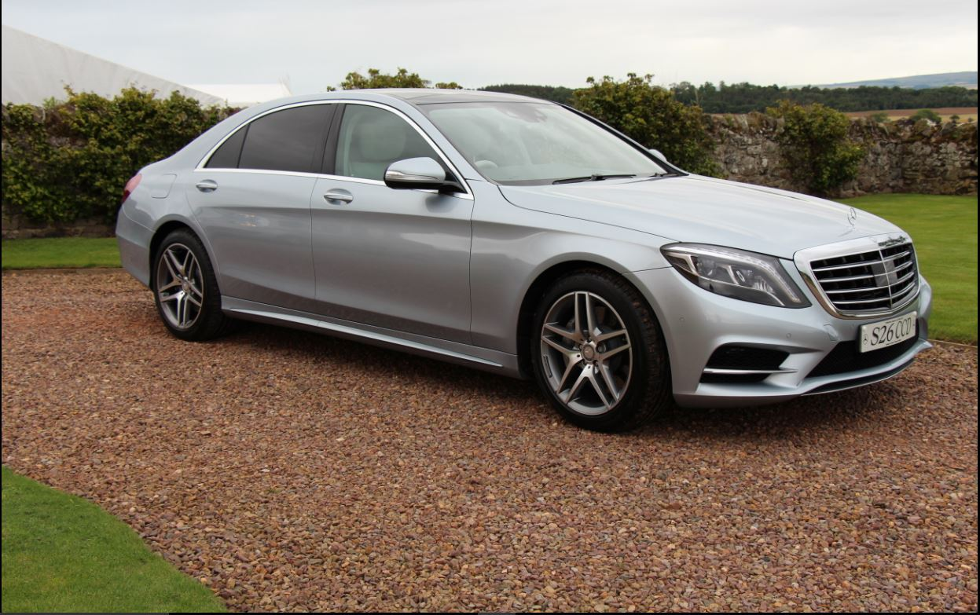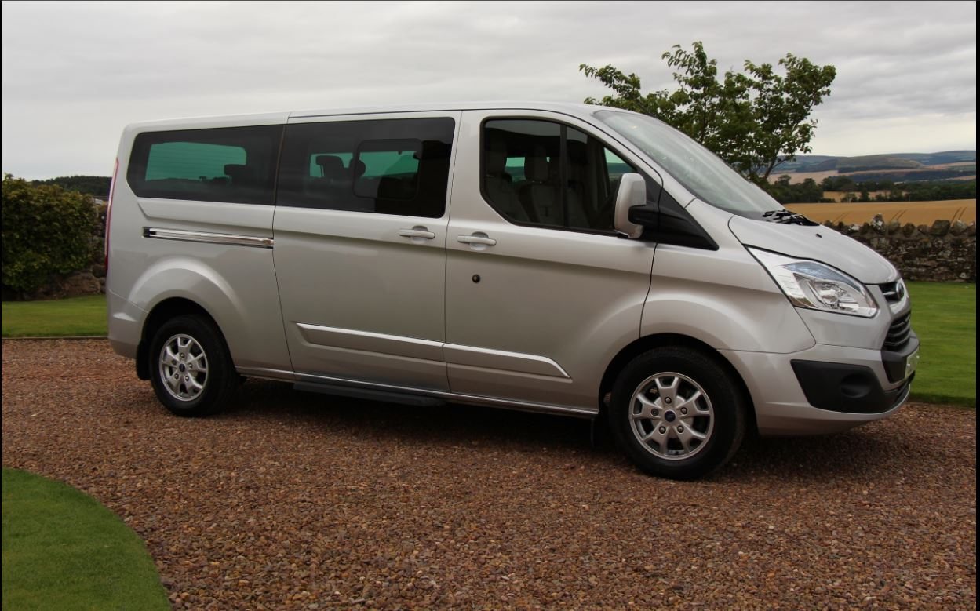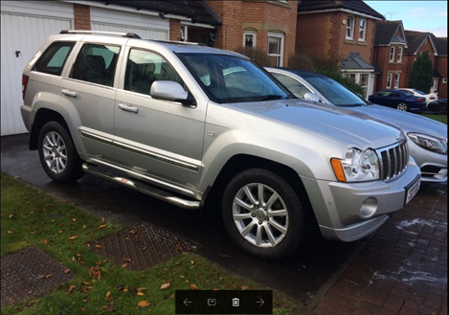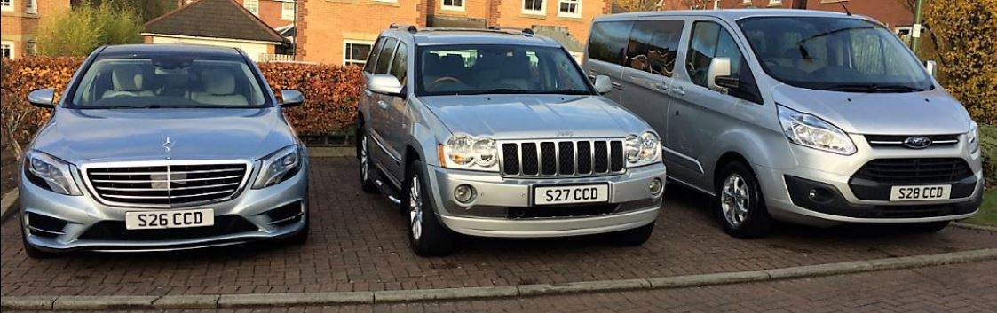
Special Rates for Client’s travelling on a weekly basis Luxury Car Chauffeur Services Scotland.
Airport Transfers, Financial Roadshows, Sporting/Social Event Transfers, City to City Transfers, Scotland Tours,
City Tours, Wedding Cars, Evening Dining Transfers.
Latest Model Mercedes S Class AMG LWB Limousine
Ford Tourneo Custom ( Titanium Model ) 8 Passenger People Carrier
Jeep Grand Cherokee Overland 4x4
Tel’+44(0)131 654 2200-Mb+44(0)7881 406 360
info@eoscs.co.uk-www.achauffeur.com

