**Butchery**

|  |  |
| --- | --- |
| **Meat** | **Please give approx. weight** |
| **Venison** Haunch / Loin / Diced etc. |  |
| **Beef** Rib / Sirloin / Topside etc. |  |
| **Pork** Boneless Leg / Loin etc. |  |
| **Gammon Joints**  Smoked or Unsmoked |  |
| **Cooked Ham** Plain or Honey Roast |  |
| **Lamb** Leg / Shoulder / Rack etc. |  |
| **Other** |  |

|  |  |  |  |
| --- | --- | --- | --- |
| **Sausages** | **6** | **12** | **24** |
| Cocktail (£11.59/kg) |  |  |  |
| Chipolatas (£11.49/kg) |  |  |  |
| Farmhouse (£10.90/kg) |  |  |  |
| Pigs in Blankets Cocktail (£16.95/kg) |  |  |  |
| Pigs in Blankets Chipolatas (£16.95/kg) |  |  |  |
| Sausagemeat 454g pack (£10.90/kg) |  | | |

**PLEASE NOTE:** Prices may be subject to change

|  |  |
| --- | --- |
| First Name: |  |
| Surname: |  |
| E-mail: |  |
| Address: |  |
| Phone: |  |
| Collection Date: |  |

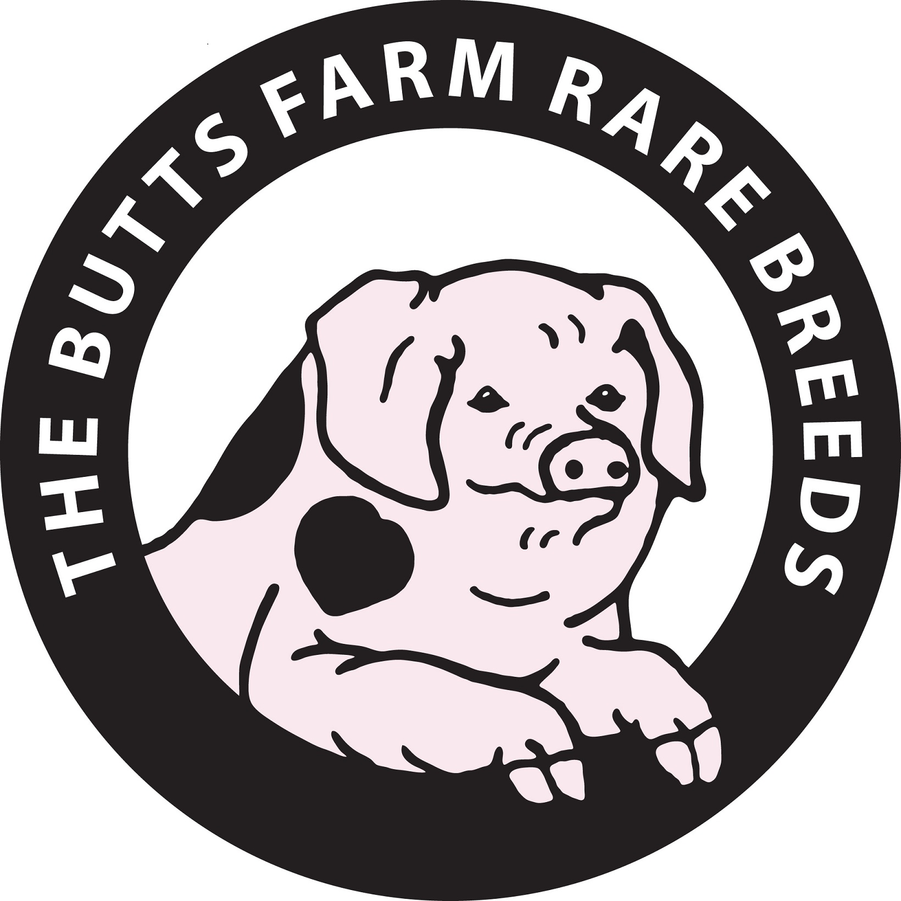

**Free Range Turkey**

|  |  |  |  |
| --- | --- | --- | --- |
| **Weight (kg)** | | **Price** | **Order** |
| 4.5-4.99 | Approx. servings 4-6 | £70 |  |
| 5 | Approx. servings 6-8 | £75 |  |
| 5-5.6 | Approx. servings 8-10 | £80 |  |
| 6-6.5 | Approx. servings 10-12 | £85 |  |
| 6.5-6.9 | Approx. servings 10-12 | £90 |  |
| 7-7.5 | Approx. servings 12-14 | £95 |  |
| 7.5-7.9 | Approx. servings 12-14 | £99 |  |
| 8.0Kg | Approx. servings 14-16 | £105 |  |
| 9.0Kg | Approx. servings 16-18 | £110 |  |
| 10Kg | Approx. servings 18+ | £115 |  |

**Poultry / Meat**

|  |  |  |  |
| --- | --- | --- | --- |
| **Bacon** | **½lb** | **1lb** | **2lb** |
| Unsmoked Streaky |  |  |  |
| Smoked Streaky |  |  |  |
| Unsmoked Back |  |  |  |
| Smoked Back |  |  |  |
|  |  |  |  |
| Cheeses |  |  |  |
| Eggs |  |  |  |
| Bread |  |  |  |
|  |  |  |  |
| Vegetables |  |  |  |
|  |  |  |  |
|  |  |  |  |
|  |  |  |  |
|  |  |  |  |
|  |  |  |  |
|  |  |  |  |
|  |  |  |  |
|  |  |  |  |

|  |  |  |
| --- | --- | --- |
| **Item** | **Price** | **Approx. Size Required** |
| Turkey Crown (3-8Kg) | £21.25/Kg |  |
| Free Range Cockerel | £15.95/Kg |  |
| Free Range Chicken | £8.65/kg |  |

**From the Deli**

|  |  |  |
| --- | --- | --- |
| **Item** | **Price** | **Quantity** |
| Pork Pie |  |  |
| Pork Pie |  |  |
| Sausage Rolls | £3.50 each |  |
| Scotch Eggs | £2.95 each |  |
| Other |  |  |
|  |  |  |
|  |  |  |
| Condiments |  |  |
|  |  |  |
|  |  |  |
|  |  |  |

**Alternatively**,

**Call** the shop on 01285862224 or

**Email** [tarryn@buttsfarmshop.co.uk](mailto:tarryn@buttsfarmshop.co.uk)

To place your Christmas order