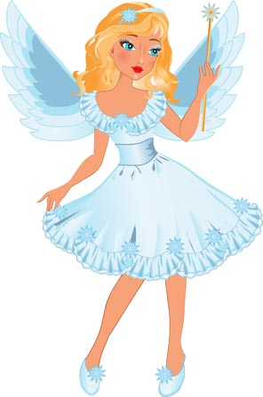

MRS B THE

IRONING FAIRY

\*\*\*\*NEW AREAS ADDED\*\*\*

HORSTED KEYNES, LINDFIELD AND HAYWARDS HEATH AND DANEHILL

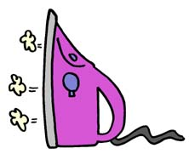

HATE IRONING?

WISH YOU HAD A FAIRY THAT DID IT FOR YOU ON A WEEKLY OR ONE OFF BASIS?

WELL YOUR WISHES CAN COME TRUE!!

I WILL COLLECT YOUR IRONING AND DELIVER IT BACK 48 HOURS LATER .

I PROVIDE THE BOX ALL YOU HAVE TO DO IS LOAD IT UP.

30 LITRE BOX- £15.00 (ideal for a couple)

60 LITRE BOX- £25.00 (ideal for a family of 4)

TERMS AND CONDITIONS APPLY

CALL ME NOW ON 01825 791875