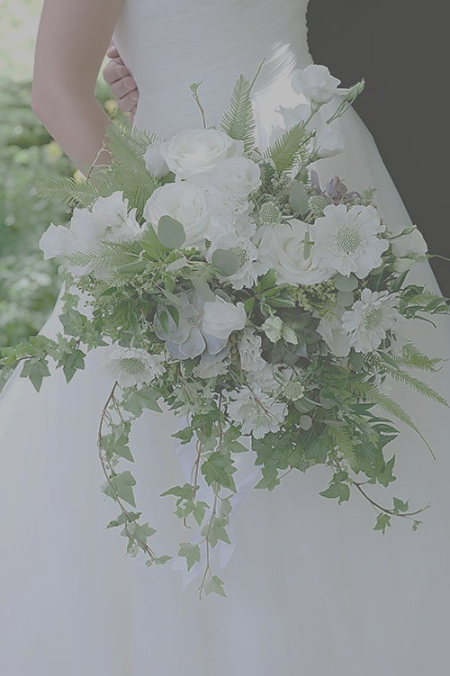
Beautiful Lily Florist
Wedding Flowers 2019
Tel: 01446 677010 Email: beautifullilyflorist@outlook.com
92 High Street, Barry. CF62 7DY

Bride:
Hand-tied from £80 - £110
Shower from £90 - £125

Bridesmaids:
Hand-tied from £35 - £60
Basket from £25 - £45
Wand from £15 to £25

Hair Accessories:
Alice Band from £20
Half Crown from £30
Full Crown from £40
Slide from £15
Wired Flower from £5.50

Button Holes:
Gents single flower from £5.50
Gents Modern Mix from £9
Ladies single flower from £6
Corsage from £9.50
Bag Corsage from £15
Wrist Corsage from £10

Table Décor:
Long & Low from £55 - £170 (can be used for both registry desk and top table)
Garland mix flower from £35 per metre
Garland Greenery from £25 per metre
Table centre piece from £30 - £120
Jars and small vases from £12 - £25

Church/Venue Flowers:
Pedestal from £75 - £180
Window from £35 - £95
Arch from £350 - £80
Cake Clusters from £10 - £30

