

Westcountry Supply Co.

Your Local Supplier for: -

Static & Mobile Shelving

Pallet Racking

Lockers

Workbenches

Cupboards

CNC Tool Storage

Drawer Cabinets

Van Racking & Storage

And all types of Storage and Handling Equipment, from plastic containers to pallet trucks.

We are also able to source many more products to save you time and money!

[](http://lionsteel.co.uk/graphics/gallery/mobile-shelving/newcastle1-large.jpg)

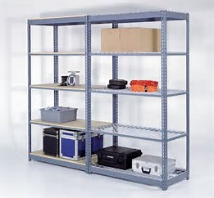

[](http://lionsteel.co.uk/graphics/gallery/lockers/Lockers-01118.jpg)

Full advice, design, quotation and installation service.

No obligation site visit to assess your requirements

