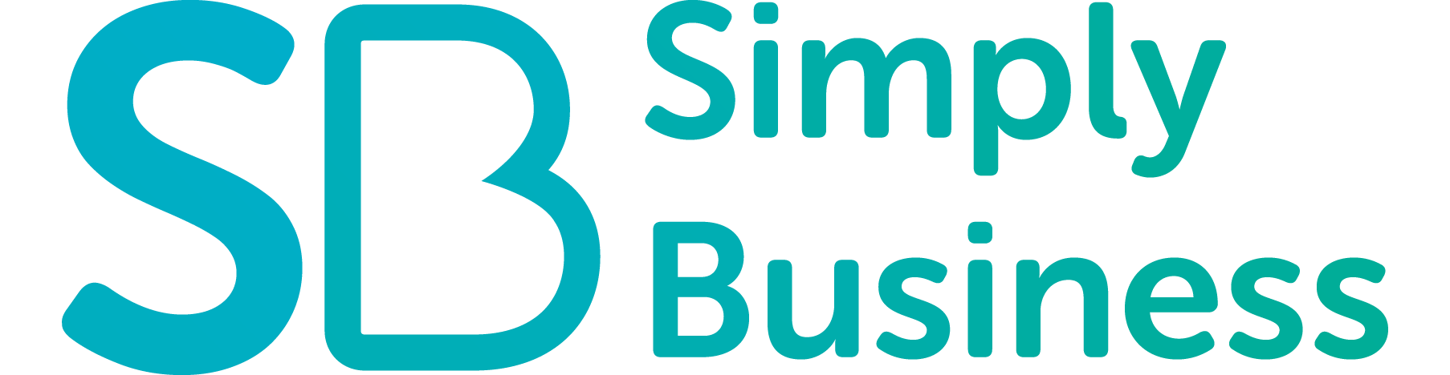 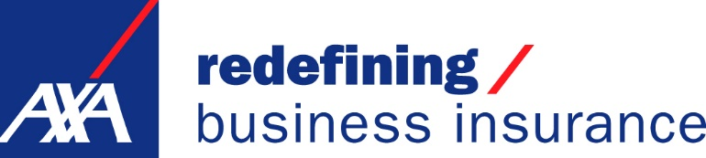
Certificate of Insurance
Issue date: 16 September 2017
Simply Business certifies that the information for williamsedgewick Developments Ltd shown here is correct, as of the issue date above.
For full policy terms and conditions, please refer to the policy wording document.
Company name | williamsedgewick Developments Ltd
Policy number | AXBI1206804XB
Trade/Business | Builder
Public liability | up to £2,000,000
Employers liability | up to £10,000,000
Policy start date | 16 September 2017
Policy end date | 15 September 2018
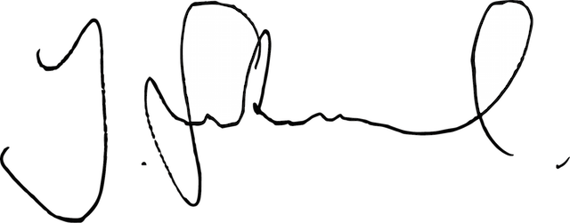
Jason Stockwood
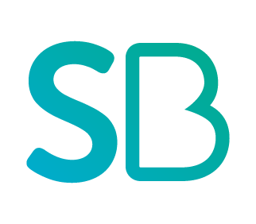
Chief Executive Officer, Simply Business
Simply Business is a trading name of Xbridge Limited which is authorised and regulated by the Financial Conduct Authority (Financial Services Registration No: 313348). Xbridge Limited (No: 3967717) has its registered office at 99 Gresham Street, London EC2V 7NG. VAT registration no: 756 9857 98.

