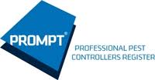
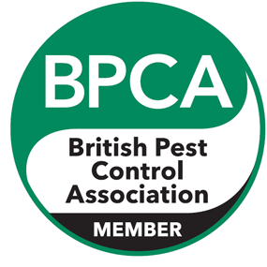
PEST SPECIALISTS
RKD

A little info about us…

- PEST CONTROL
- PEST PROOFING
- FREE SURVEYS
- SUB-CONTRACTOR
- BIRD CONTROL
- DOMESTIC
- COMMERCIAL
- CONTRACT WORK
- UNMARKED VEHICLES
- FULLY QUALIFIED & INSURED
- BPCA REGISTERED
- BASIS PROMPT REGISTERED

Here at RKD we pride ourselves on providing a professional, discreet and effective service. We are able to remove and prevent pest infestations, ensuring your Business, Assets and more importantly your Health are protected from diseases and financial hardship. Using the latest and most innovative products we set high standards in the industry and being specially trained in dealing with the most complex infestations, your business will be protected from detrimental pests.

Take a peek inside this brief presentation to see just what we have to offer and an insight into our world of pest control. Remember it’s brief but to the point and will hopefully encourage you to give us the opportunity to prove ourselves.

We accommodate all pests, but here is a list of a few just for your convenience…
Rats & mice, squirrels, birds, mink, moles, ants, wasps, flies, fleas, cockroaches, stored product insects (spi’s), public health pests and many more…
CALL RYAN ON: 07934467725
EMAIL: rkd-pest@hotmail.com

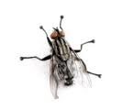
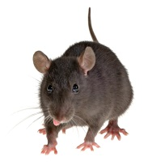
The breakdown
We do things differently at RKD. Instead of working for you we will work with you. We can train you the very basics in pest control, so that you can identify pest activity when we aren’t there, after all you are our eyes and ears in between visits. It is vital that any activity is recorded so it can be acted upon immediately. This is working together at its best. It builds a trust between us and that goes a long way in business. We have specific industry training, an “outside of the box” mentality. We have dealt with the most complex infestations imaginable, in the most delicate environments. We will go the extra mile for your business, we haven’t failed and we definitely don’t accept second best. Like the great Bill Shankly once said, “If you are first you are first, if you are second you are nothing” Maybe a little harsh but that’s a mentality to success. We can accommodate any situation. Whether it’s an ant treatment, full contract or a complete bird proofing job then don’t hesitate to call us. We are a new set up and we can understand doubt in people’s minds but we aren’t here to fail, and we won’t.

The cost

If it’s a contract you want then what we will do is carry out thorough inspections on scheduled visits to your premises and, if we find evidence of ants/silverfish or minor insect pests we will treat them free of charge. Any treatments for non-contract pests, (these will be determined prior to contract) will be charged at just £15. There’s no call out charges. Please understand that due to the threat wasps pose these will be treated at £30 for call outs or if found during visit, this is still by far the cheapest price throughout the industry! All pests covered in the contract will be agreed beforehand. If you don’t need or fancy a contract then we have set prices for on-off jobs. With rats and mice this is a minimum 3 visit treatment costing just £120. Ants are just £25. All stored product and public health pest treatments and prices will be discussed as this will require a more in-depth approach.

Don’t hesitate to call us for a free no obligation survey. There are no salesmen, just a fully qualified and committed technician to talk you through your needs. Thank you for your time and attention. We look forward to working with you.
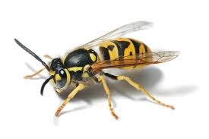
Yours faithfully

Ryan Doyle

