WALKER’S PC AND LAPTOP REPAIR 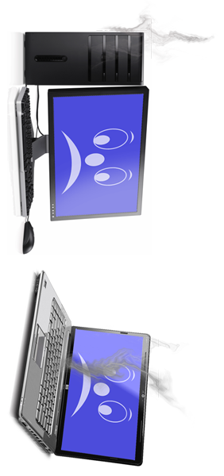

PRICE LIST

Desktop & PC Repair -25.00
PC Build -25.00
Computer Recycling -25.00
PC Maintenance -25.00
Virus Removal - 25.00
Anti – Virus & Firewall Installation -25.00
Professional Data Recovery -25.00
Business IT Support -25.00
Wireless and Wired Router Setup -25.00
Laptop Repair -25.00
Computer Hard were - 25.00
Computer sorthwere - 25.00
Computer formate - 25.00

