ENVIRO-FRIENDLY PRODUCT RELIEVES ATHLETES PAIN

**Thanks to a revolutionary new product, runners, joggers, and cyclists can now enjoy pain free exercise whilst simultaneously helping the environment.**

**The new product manufactured in the UK by TCB Arrow Camberley, is designed to replace the “throw away” alternatives which prevent soreness in sensitive areas.**

Managing Director Michelle Jarman came up with the idea whilst suffering embarrassment when wearing her polo shirt uniform. She commented “It was

such a simple idea, I then started to think if athletes could benefit, from this and it just went from there”.

The new product is Silicone based and is designed to stay in place, with body heat instantly preventing soreness during sporting activities.

4% of males who run on average 24K a week, report suffering. That equates to 12,423,200 runners.

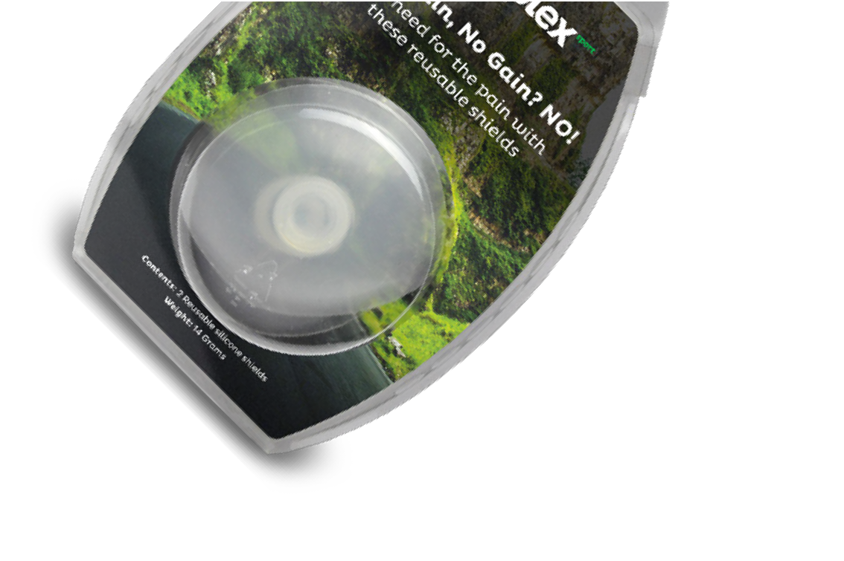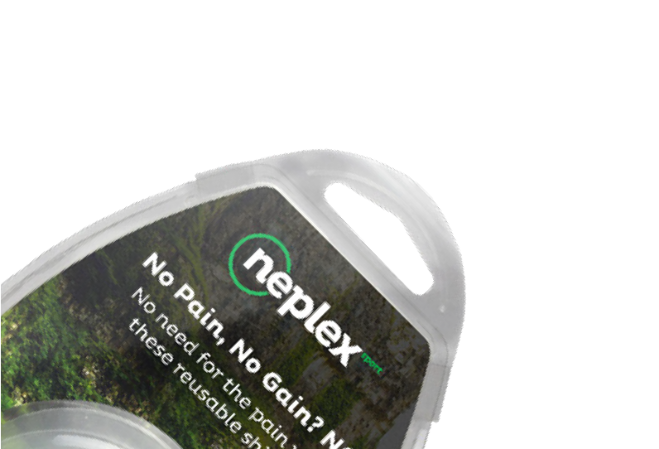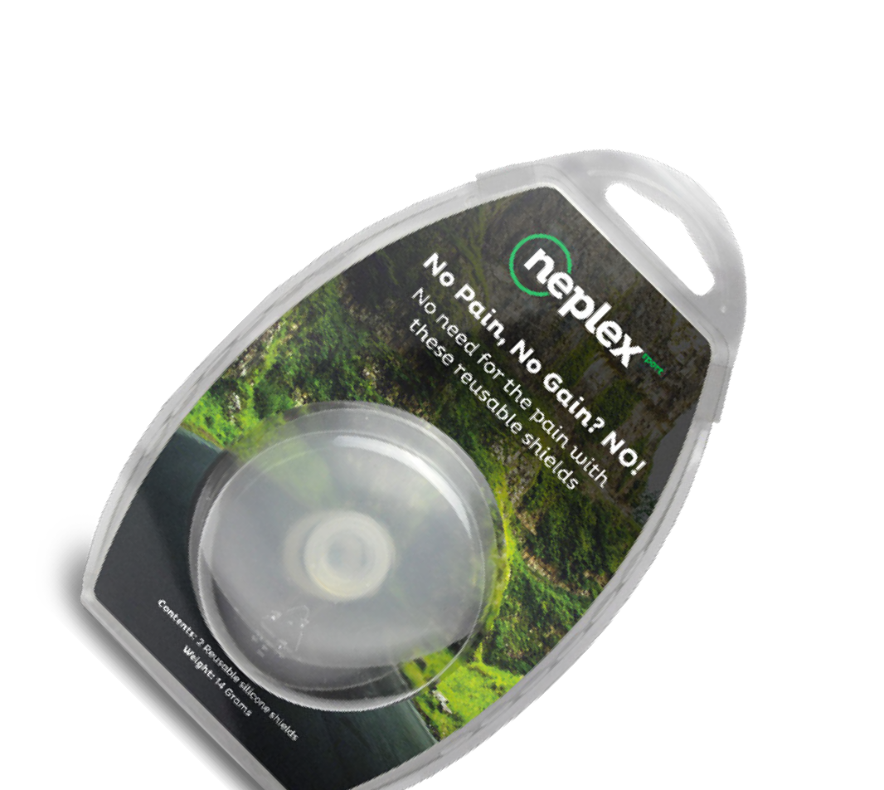

Over a 5 year period

25% of males who run on average 60K a week, report suffering. That equates to 77,645,000 runners.

So, just based on the lower figure, a runner using the plasters five days a week will dispose of 2600 plasters over a 5 year period.

**Times that by the 4% of runners means 32,300,320,000 plasters or equivalent going to landfill over 5 years and could save each runner over £110.**

# Is due to Launch Dec 2021

**neplex**

For any further information please contact **Michelle Jarman**, Director of NEPLEX LTD [sales@**neplex**.uk](mailto:sales@neplex.uk) **|** 07379 657 557 **|** [www.**neplex**.uk](http://www.neplex.uk/)