Traditional Indian Head Massage | 30 minutes | £35
The second option is; Modern Head Massage which is carried out whilst lying down, massage oil is applied to the skin and hair. The massage will begin on your arms, then move to your upper back, shoulders and neck, you will then turn over and the treatment will continue on your scalp and face.
Modern Head Massage | 35 minutes | £35
Reflexology Treatments
The ancient art of Reflexology is used to treat specific conditions or for a soothing, calming effect on the whole body. Based on applied massage and stimulation of reflex points located in the feet. Regular reflexology can promote healing and a more balanced way of life. The full treatment targets the whole body but a mini treatment can be selected to treat specific conditions or as a taster.

Full Reflexology Treatment | 45-50 minutes | £40
Mini Reflexology Treatment | 25 minutes | £25
Swedish Body Massage
This ancient holistic therapy involves the manipulation of body tissues to massage and soothe away knotted muscles, everyday aches, pains and stresses.
Encounter true relaxation, calming the body, mind and spirit. Or use to stimulate the bodies systems for a toning, invigorating treatment.

Back, Neck and Shoulder Massage | 30 minutes | £30
Back, Neck, Shoulders and Scalp Massage | 45 minutes | £35
Treatment Packages
Available year-round. These get updated regularly so please see website for latest packages.
www.tranquilityroom.co.uk
Tranquility Room MK

Address; 50 Sakura Walk, Willen Park South, Milton Keynes, Buckinghamshire,
MK15 9EH

Once in Sakura Walk, take the first turning on the right and we are the last house on the right.
Visitor parking spaces directly outside.

Contact us;
07941576219
www.tranquilityroom.co.uk
www.facebook.com/thetranquilityroom
www.instagram.com/the_tranquility_room
Laura@tranquilityroom.co.uk

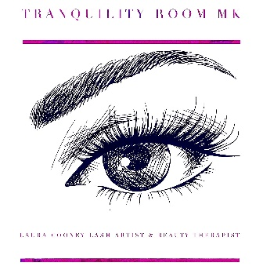

Tranquility Room MK
Price list and Treatment Details
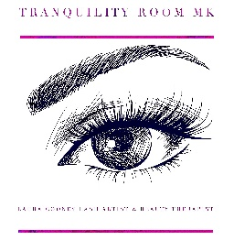
Holistic Treatments
Clinical Aromatherapy Massage
All essential oils and carrier oils are soil association certified 100 % pure organic and free from parabens. Experience the wonderful deep physical and holistic healing properties of an aromatherapy massage. This is a luxurious treatment specifically tailored to your Individual requirements. During a 15 minute consultation, we will discuss your physical and mental wellbeing and agree the areas you want to focus on. We then make you a personal essential oil blend that will treat your individual requirements so you get maximum benefit from the massage treatment.
Back, Neck and Shoulder Massage | 30 minutes | £40
Back, Neck, Shoulders & Scalp Massage | 45 minutes | £45
Indian Head Massage
This is an excellent treatment for relieving stress, tension, fatigue, insomnia, headaches, migraines and sinus problems. The experience is deeply calming and relaxing, leaving you feeling energised and revitalised.
Two different options for you to choose from.
The first is; Traditional Indian Head Massage which is carried out in a seated position, over clothes and
concentrates on your arms, upper back, neck, shoulders scalp and face.
Beauty Treatments
Nail Treatments
*French Polish Additional £5 & additional 15 mins
Treatment | Time | Cost £
Manicure with Gel Polish* | 60 minutes | £30
Pedicure with Gel Polish* | 60 minutes | £30
Gel Polish* | 45 minutes | £20
Gel Soak off and reapply | 60 minutes | £25
Gel Polish Indvidual Nail Repair | 15 minutes | £3 or free in first 5 days
Gel Removal & Strengthener | 30 minutes | £10
Gel Nail Extensions - The Gel Bottle inc. Products
Gel Extensions with tips and gel polish | 90 minutes | £25
Gel Extensions infills and new colour | 50 minutes | £15
Gel Extensions removal | 30 minutes | £10
Event Make Up & Hair Styling
Make up for prom/event | 60 minutes | £15
Hair Styled | 30 minutes | £10
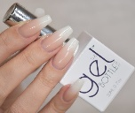
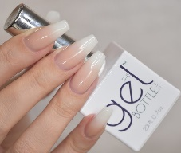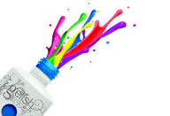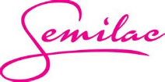
Eyelash Extension Treatments

-Classic Individual Eyelash Extensions are one eyelash extension being glued to a well isolated individual natural eyelash. This is a beautiful natural look that can be enhanced by using different weight and length lashes and ellipse flat lashes can also be used to create a darker set of lashes.

-Pre-made fans of 3 or 4 lighter lashes are glued to a well isolated individual natural lash, this gives a fluffier look. * Not the same as handmade Russian Volume but a good option if you want more than individual lashes.

-Cluster / Flare / Party Lashes Known as all these names. Temporary lashes that can be applied for an event/maximum a weekend. The cluster lashes are applied using a different glue to the above and are placed on top of the lashes (not individually placed on each lash) but can be a great alternative to strip lashes.

Patch Test * Mandatory for all clients | 15 minutes | Free
Classic Individual  Full Set | 90-120 minutes | £50
Classic Individual Infills 2 weeks | 60 minutes | £25
Classic Individual Infills 3 weeks | 75 minutes | £30
Premade fans Full Set | 90-120 minutes | £60
Premade Infills 2 weeks | 60 minutes | £30
Premade Infills 3 weeks | 75 minutes | £35
Full Set Party Lashes | 20 minutes | £20
Lash, Brow Tinting & Shaping Treatments
Tint Patch Test | 15 minutes | Free
Eyelash Tint | 20 minutes | £12
Eyebrow Tint | 15 minutes | £8
Eyebrow Tint & Shape | 30 minutes | £15
Eyebrow Shape | 15 minutes | £8
Fake Bake Spray Tan Treatments
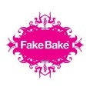
See website for preparation guidelines, follow these for better, longer lasting results.
Fake Bake is the UK’s leading salon professional spray tan brand. You will experience an instant sun-kissed colour developing into a golden sunless fake tan lasting approximately 5-7 days dependent on your preparation / aftercare routines. Spray tanning is the safest way to tan! No harmful UV rays!
Beyond Bronze ‘Weekend Tan’ | 20 minutes | £15
Original Tan  ‘5-7 days’ | 20 minutes | £22
60 Minute Tan  ‘5-7 days’ | 20 minutes | £25
Darker Tan  ‘5-7 days’ | 20 minutes | £25
