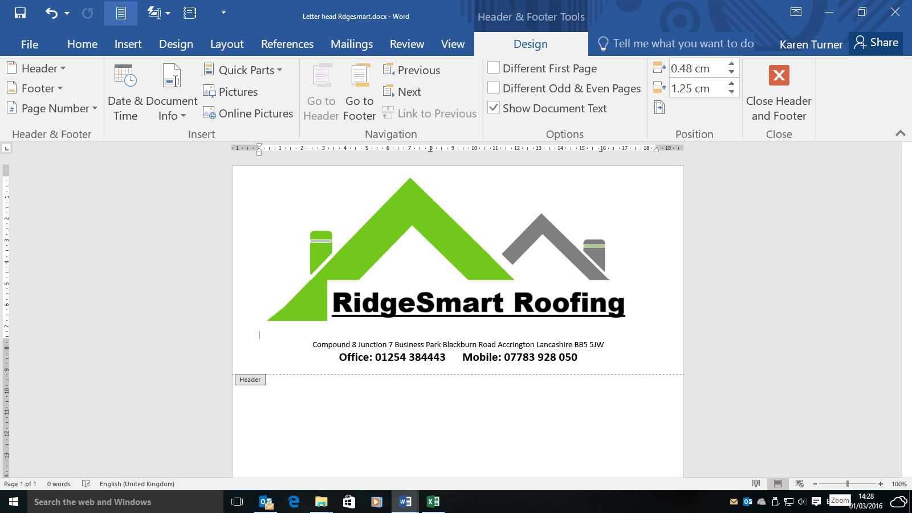

Unit 2A Moorfield Drive Moorfield Industrial Est Altham BB5 5WG

**Office 01254 384443** **Mobile 07989 512 574**

Unit 2A Moorfield Drive Moorfield Industrial Est Altham BB5 5WG

**Office 01254 384443** **Mobile 07989 512 574**

**All Work Fully Insured & Guaranteed**

**All Work Fully Insured & Guaranteed**



**Got a leak need a small repair**

* **Replacement lead flashing**
* **Slate replacement**
* **Re-bed coping stones**
* **Chimney repoint**

**Need a more extensive work**

* **Full re-roof**
* **Full chimney removal and slate/tile over**
* **Complete dry verge system**
* **All aspects of Flat roofing**

**Finishing Touches**

* **Gutter clean**
* **Gutter replacement**
* **Facia soffit replace**
* **Specialist roofing contractors**

**For all your roofing works**

**Call: 01254 384443 or 07989 512574**

**Got a leak need a small repair**

* **Replacement lead flashing**
* **Slate replacement**
* **Re-bed coping stones**
* **Chimney repoint**

**Need a more extensive work**

* **Full re-roof**
* **Full chimney removal and slate/tile over**
* **Complete dry verge system**
* **All aspects of Flat roofing**

**Finishing Touches**

* **Gutter clean**
* **Gutter replacement**
* **Facia soffit replace**
* **Specialist roofing contractors**

**For all your roofing works**

**Call: 01254 384443 or 07989 512574**

